# CS 255 System Design

# Devyn Mustard

## UML Diagrams

### UML Use Case Diagram:

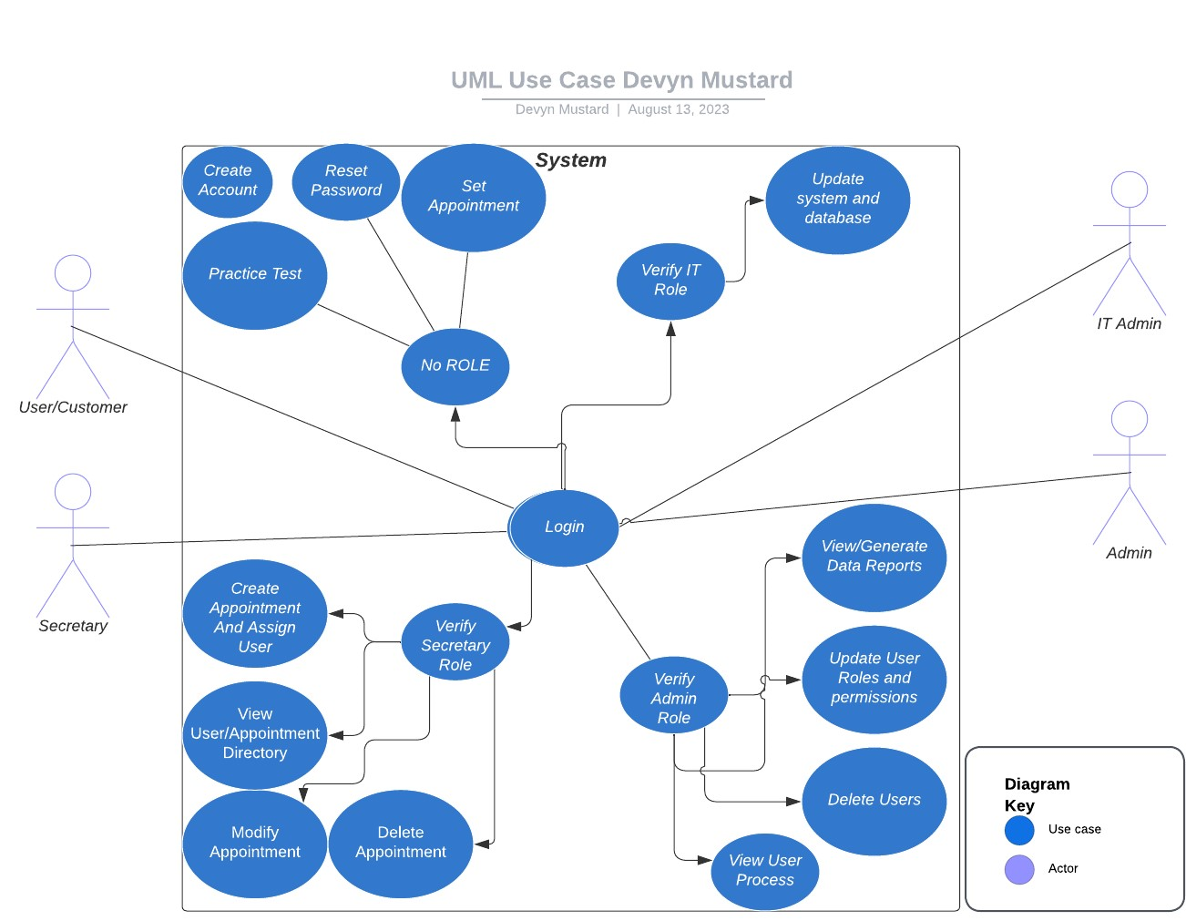

### UML Activity Diagrams

Account Creation Activity Diagram: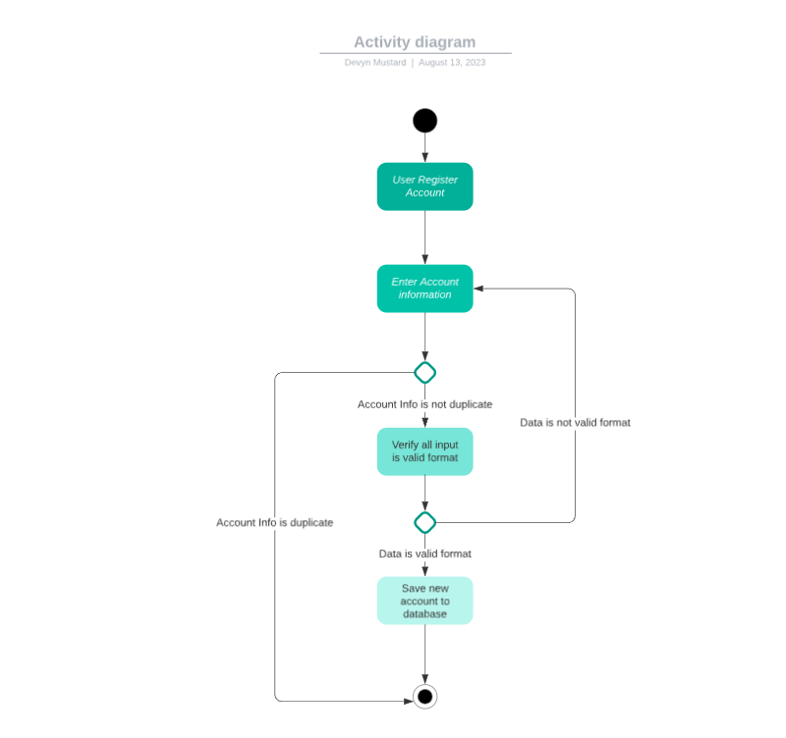

Appointment Creation Activity Diagram: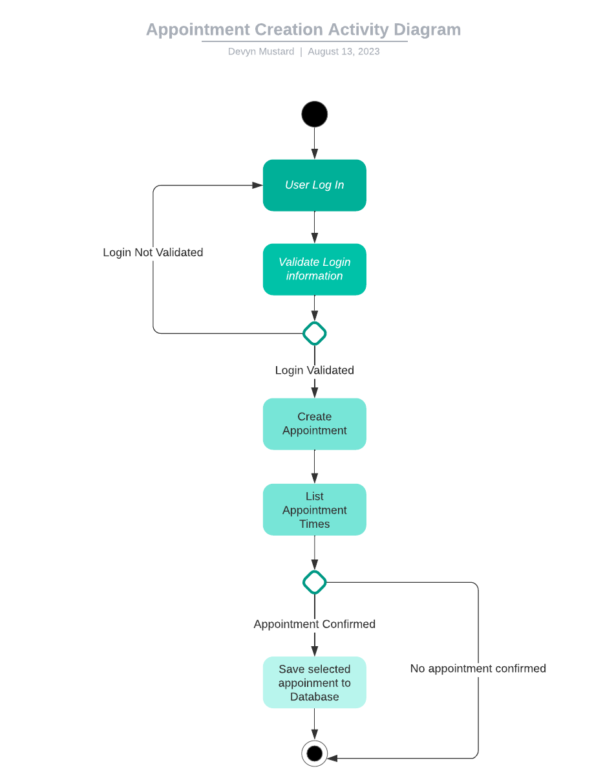

### UML Sequence Diagram

Appointment Creation Sequence Diagram:

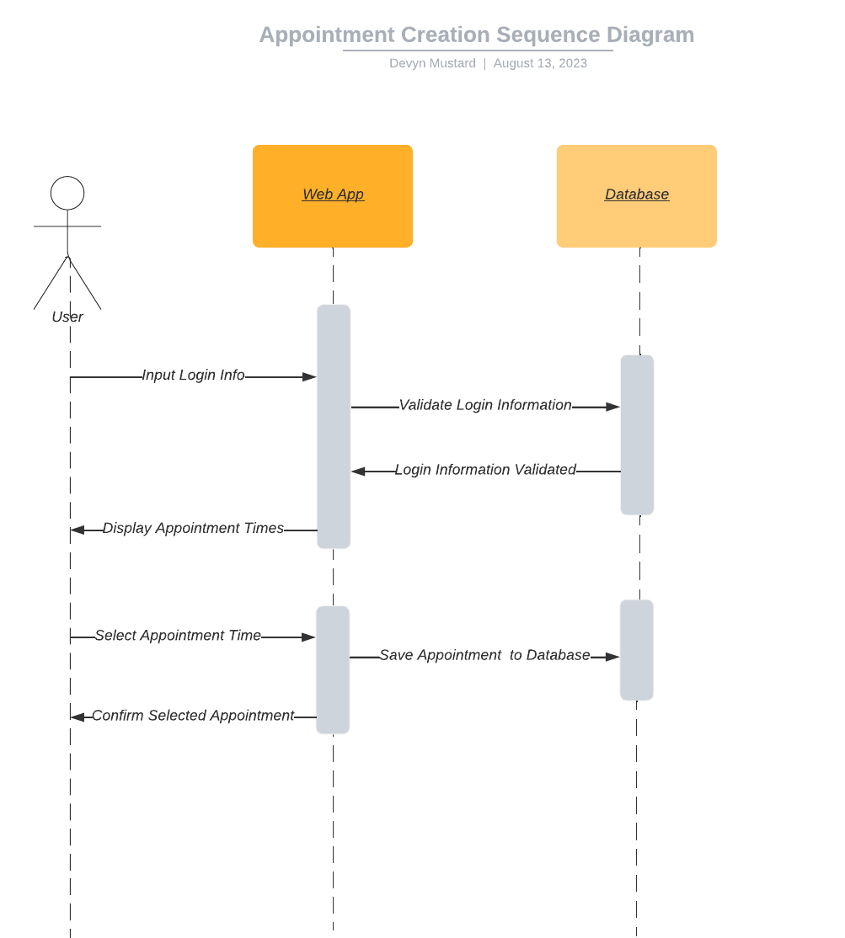

### UML Class Diagram

### 

## Technical Requirements

*The DriverPass system will need to be hosted as a cloud-based web-application. This choice will allow for the system to be accessed at anytime and anywhere as requested by the DriverPass team. The team needs to be able to view their appointments and generate reports from any device to keep up with business needs. The web application also needs minimal upkeep, so hosting to a cloud-based solution requires less maintenance and ensures a high uptime with minimal outages. Any hardware that has access to a webpage will be able to access the DriverPass system and will be able to use it to the full. Along with the WebApp, the database needs to be hosted so that user data can be stored and accessed on the fly as needed. This data will all be encrypted so that no attackers have access to user information or any sensitive data. Hosting the web-application and database through AWS would ensure the needed high uptime and low maintenance required. The web-application will be a responsive application developed with HTML, CSS, JavaScript, utilizing AWS’ built-in database to store information for a high level of security. The system needs to be created with growth in mind, as more appointments are created, and more data needs to be stored.*